Assignment No. 3

Q.1 Loan Amortization Calculator (without getter setter).

Solution :

import java.util.*;

class LoanAmortizationCalculator{

double principal;

double annualIR;

int loanTerm;

double monthlyPayment;

double totalPayment;

public void acceptRecord(){

Scanner sc = new Scanner(System.***in***);

System.***out***.println("Enter the principal amount: ");

this.principal = sc.nextDouble();

System.***out***.println("Enter the annual interest: ");

this.annualIR = sc.nextDouble();

System.***out***.println("Enter the loan term (in years): ");

this.loanTerm = sc.nextInt();

}

public void calMonthlyPayment() {

double monthlyIR = annualIR / 12 / 100;

int numMonth = loanTerm * 12;

this.monthlyPayment = principal * (monthlyIR * Math.*pow*( 1 + monthlyIR,numMonth)) / (Math.*pow*( 1 + monthlyIR, numMonth) - 1 );

this.totalPayment = monthlyPayment * numMonth;

}

public void printRecord() {

System.***out***.printf("Monthly Payment: %.2f%n", monthlyPayment);

System.***out***.printf("Total Payment: %.2f%n", totalPayment);

}

}

public class Program{

public static void main(String[] args) {

LoanAmortizationCalculator calculator = new LoanAmortizationCalculator();

calculator.acceptRecord();

calculator.calMonthlyPayment();

calculator.printRecord();

}

}

Output :

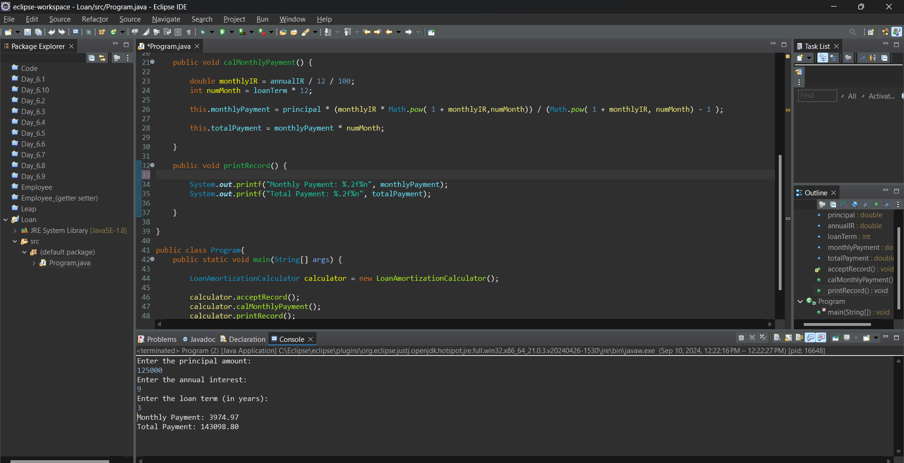

Q.2 Compound Interest Calculator for Investment(Without getter setter)

Solution:

import java.util.*;

class CompoundInterestCalculator{

double principal;

double annualIR;

int numCompounds;

int years;

double futureValue;

double totalInterest;

public void acceptRecord() {

Scanner sc = new Scanner(System.***in***);

System.***out***.println("Enter the initial investment amount: ");

this.principal = sc.nextDouble();

System.***out***.println("Enter the Annual Interest Rate: ");

this.annualIR = sc.nextDouble();

System.***out***.println("Enter the number of times the interest is compounded per year: ");

this.numCompounds = sc.nextInt();

System.***out***.println("what is the durtion of investment n years: ");

this.years = sc.nextInt();

}

public void calFutureValue() {

double rate = annualIR / 100; //percent ot decimal

this.futureValue = principal * Math.*pow*((1 + rate) / (numCompounds) , (numCompounds * years));

this.totalInterest = futureValue - principal;

}

public void printRecord() {

System.***out***.printf("Future value with the provided information is: " + futureValue);

System.***out***.print("The total interest in rupees: " + totalInterest);

}

}

public class Program {

public static void main(String[] args) {

CompoundInterestCalculator calculator = new CompoundInterestCalculator();

calculator.acceptRecord();

calculator.calFutureValue();

calculator.printRecord();

}

}

Output :

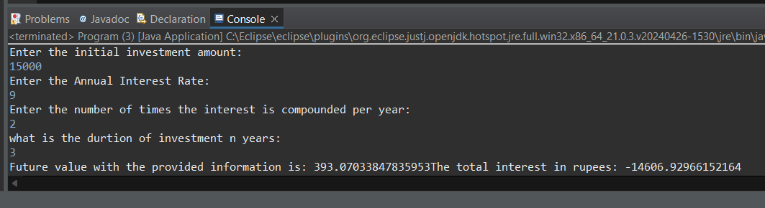

Q.3 BMI Tracker

Solution :

import java.util.*;

class BMITracker {

private double weight;

private double height;

private double bmi;

private String classify;

public void acceptRecord() {

Scanner sc = new Scanner (System.***in***);

System.***out***.println("Enter the weight in kg. : ");

this.weight = sc.nextDouble();

System.***out***.println("Enter the height in metres : ");

this.height = sc.nextDouble();

sc.close();

}

public void calculateBMI() {

this.bmi = weight / (height * height);

}

public void classifyBMI() {

if (bmi < 18.5) {

classify = "Underweight";

}else if(bmi>=18.5 && bmi< 24.9) {

classify = "Normal Weight";

}else if(bmi >= 25 && bmi < 29.9) {

classify = "Overweight";

}else {

classify = "Obese";

}

}

public void printRecord() {

System.***out***.printf("Your BMI is: %.2f\n ",bmi);

System.***out***.printf("You are classified as: "+classify);

}

}

public class Program {

public static void main(String[] args) {

BMITracker tracker = new BMITracker();

tracker.acceptRecord();

tracker.calculateBMI();

tracker.classifyBMI();

tracker.printRecord();

}

}

Output: 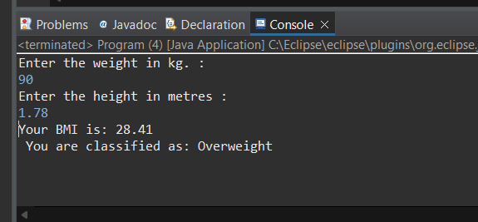

Q.4 Discount Calculation for Retail Sales

Solution :

import java.util.*;

class DiscountCalculator{

private double originalPrice;

private double discountRate;

private double discountedAmount;

private double finalPrice;

public void acceptRecord() {

Scanner sc = new Scanner(System.***in***);

System.***out***.println("Enter the original price of the product: ");

this.originalPrice = sc.nextDouble();

System.***out***.println("Enter the discount percentage: ");

this.discountRate =sc.nextDouble();

sc.close();

}

public void calculateDiscount() {

this.discountedAmount = originalPrice * (discountRate / 100);

this.finalPrice = originalPrice - discountedAmount;

}

public void printrecord() {

System.***out***.printf("Discount Amount: %.2f\n",discountedAmount);

System.***out***.printf("Final Price after discount: %.2f\n",finalPrice);

}

}

public class Program {

public static void main(String[] args) {

DiscountCalculator calculator = new DiscountCalculator();

calculator.acceptRecord();

calculator.calculateDiscount();

calculator.printrecord();

}

}

Output :

